Tuesday 9th February 2021
LO: to know the features of a Mandir – a Hindu Temple
Complete the table by filling in the missing information.
Object | Name | Description
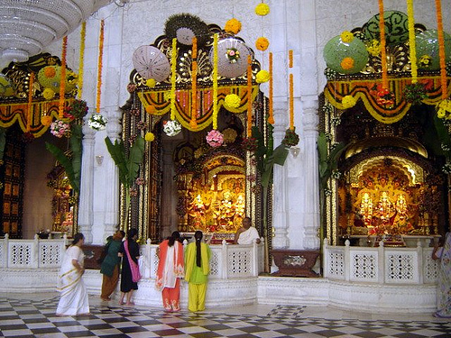
 | Shoe Rack
 |  | This is the main sacred text of Hinduism. It guides Hindus in their daily life and faith. It is written in Sanskrit and is kept safe in a special case.

 | Bell
